A Breath of Fresh Air
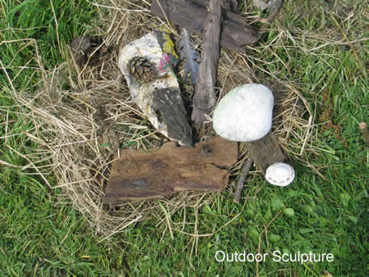
This formed part of Ecominds, a national project funded by the Big Lottery, via Mental Health charity Mind. Through a wide variety of arts activities we gave people gentle encouragement to be more physically active and enjoy their environment. This led to working with lots of other groups (e.g. Rethink at John Hall Gardens; Kniveden Partnership; Stone & Water Artists' Collective; Project eARTh; Dove Valley Centre), sometimes at their venues.
Final Evaluation of the "Breath of Fresh Air" project. click

